GMEPay+
Global QR Payment Hub
Product Requirements Document — PRD-01: Hub Core Platform
Version | 1.0 — Draft
Date | April 2026
Status | In Review
Author | GME Product Team
Audience | Leadership, Product, Engineering, Business Development

1. Background
GME operates a cross-border financial network with 70+ partner companies — banks, wallets, and fintechs. QR payment schemes are the dominant in-store payment method in every market we operate in — ZeroPay, KHQR, PromptPay, VietQR, QPay — but each is a separate integration. An app wanting to enable cross-border QR payment today must acquire merchants directly in each destination country, which doesn't scale for any individual partner.
GMEPay+ is GME's product for this aggregator layer: one API connection gives a partner access to every supported scheme in every supported country, distributed across GME's existing partner network.

1.1 Why Now
- No aggregator currently provides a global QR solution for apps that don’t acquire merchants
- 70+ existing partners are an immediate partner base — no new partner acquisition needed to launch

1.2 The Problem We Are Solving

Who | Problem | What GMEPay+ enables
End users | Home wallet only works domestically. Cross-border payments mean cash or exclusion. | Pay at any merchant in any GMEPay+ country using their existing app.
Partner companies | Each QR scheme needs a separate legal and technical integration. Impossible at scale. | One API connection. Access to all supported schemes across all supported countries.
GME | No consolidated Global QR solution to serve both domestic and overseas customers. | New revenue from FX margin, service fees, and scheme fee sharing.

1.3 Target Markets and Expansion Priority
Non-KFTC markets are prioritised first — GME can move independently.

Priority | Country | Key partner | QR scheme
1 | Russia | T-Bank / Korona | SBP (Faster Payments)
2 | Mongolia | Sendmn | QPay
3 | Cambodia | Wing / ABA | KHQR
4 | Uzbekistan | Universal Bank | —
5 | Kazakhstan | PayForm | —
— | Korea (Phase 1) | — (inbound from partners) | ZeroPay

Full market analysis in the GME QRPay Project Plan (Feb 2026).

2. What We Are Building
Vision
GMEPay+ aims to become a Global QR Payment Hub, connecting partners (banks, wallets, and fintechs) to multiple QR ecosystems worldwide.
Through a single integration, partners can:
• Use their existing apps to pay across borders
• Access all QR schemes connected to GME
GME operates as a neutral routing and settlement layer, enabling interoperability across different QR standards and national infrastructures.
Mission
To build a unified QR connectivity platform that:
• Aggregates multiple QR payment schemes
• Supports both inbound and outbound payment flows
Korea is our starting point — not our boundary.
GMEPay+ is a payment hub — a central system that sits between payment apps and QR payment schemes. It has one job: when a payment app user wants to pay at a merchant using a QR code, GMEPay+ handles everything in between.

GMEPay+ is the only system that talks to QR payment schemes. All partners connect via a single API and have no direct connection to any scheme.
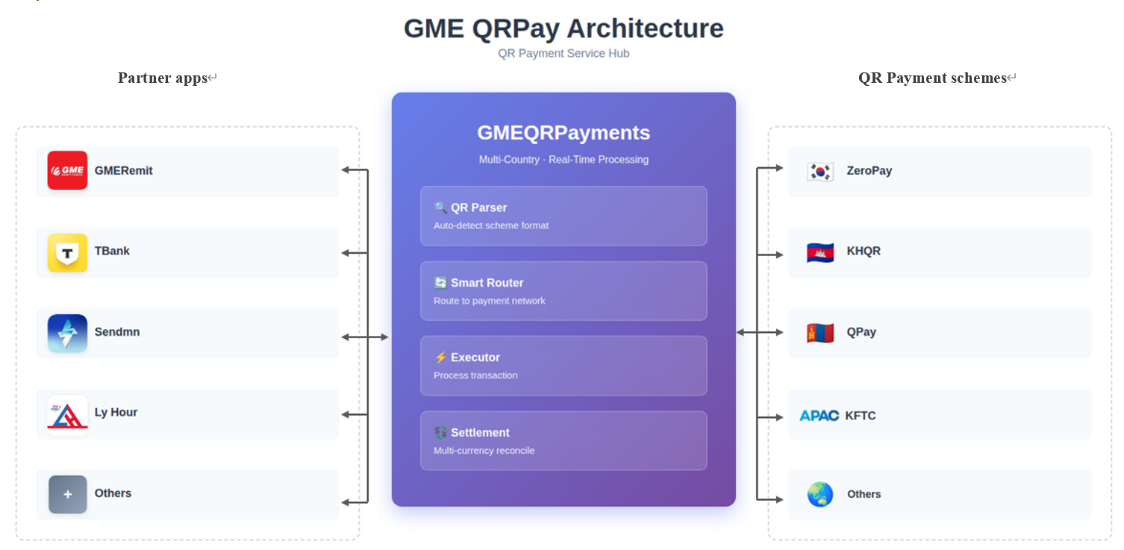
2.1 Two Types of Things GMEPay+ Manages

Entity | What it represents | First example
QR Scheme | A payment network merchants are registered with. GMEPay+ connects to process payments and receive fee income. | ZeroPay — operated by 한결원. Covers Korean merchants.
Partner | A payment app that connects to GMEPay+ to offer QR payment capability to its users. | Any of GME’s 70+ partner payment apps.

Build generically. ZeroPay is the first scheme entry, the first partner app is the first partner entry. Adding either requires only configuration — no code change.

2.2 How a Payment Works

Fixed MPM vs CPM
 | Fixed MPM | CPM
Who shows QR | Merchant | Customer
Who scans | Customer (via partner app) | Merchant POS
Payout amount source | Customer inputs in app | Merchant inputs on POS
Rate delivery | Partner pulls — GET /v1/rates | GMEPay+ pushes offer rate to partner — payment.pending_debit
Payment initiation | Partner → GMEPay+ → QR scheme | QR scheme relay → GMEPay+ → Partner
Both modes share the same rate engine, settlement model, CommitTransaction step, and payment.approved payload. GMEPay+ always provides offer_rate. The partner computes collection_amount from offer_rate — GMEPay+ never computes, passes, or validates the partner's collection amount in either direction.


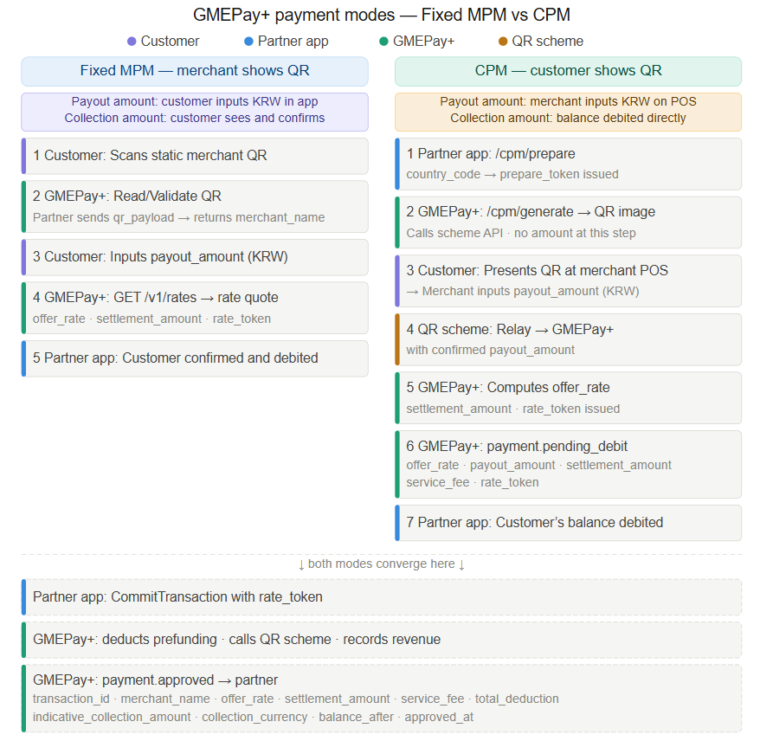

2.3 Transaction Types and Phased Expansion
GMEPay+ supports four transaction flows. The architecture supports all four phases from day one.

Scope | Transaction type | Flow | What it enables
Domestic | Domestic QR payments | Domestic wallet → GMEPay+ → scheme → merchant | Same country, same currency, no FX. E.g. GME Remit user pays at ZeroPay merchant in Korea.
Phase 1 | Inbound QR payments | Foreign wallet → GMEPay+ → scheme → merchant | Overseas partner users pay at merchants in the scheme’s country.
Phase 2 | Outbound QR payments | Domestic wallet → GMEPay+ → foreign scheme → merchant | Domestic users pay at merchants abroad.
Phase 3 | Multi-country QR | Wallet (Country A) → GMEPay+ → scheme (Country B) → merchant | Users pay across any two GMEPay+ countries.

PRD-01 covers Phase 1 only. Phases 2 and 3 are configuration additions, not architectural changes.
If the core is built for the domestic case only, adding cross-border partners later will require retrofitting the FX module, the revenue ledger, and the settlement model. This is a complete rework — not an extension.
2.4 Build Sequence
Three sequential phases. Each is a gate for the next. The core is built once.

Phase | What happens | Gate | Deliverables
1 — Build Core | Build GMEPay+ hub: scheme registry, partner registry, rate engine, settlement engine, ops portal. | Core running, API testable in sandbox. | 1.GMEPay+ backend  2.GMEPay+ frontend  3.Unified API docs + sandbox
2 — Integrate ZeroPay | Configure ZeroPay. Build and test ZeroPay protocol with 한결원 test environment. | Successful end-to-end test transaction. | 1. Zeropay shows as registered QR scheme in frontend  2.ZeroPay live in backend, all message types verified
3 — Launch with Domestic Partner | Onboard partners starting with GME Remit. Each connects via the same API. | GME Remit consumes GMEPay+ API | 1. GME remit shows as registered Partner in frontend  2.GME Remit live, first domestic partner live
4 – Launch with Overseas Partner | Onboard partners starting with T-Bank / Sendmn | T-Bank / Sendmn consumes GMEPay+ API | 1. T-Bank / Sendmn shows as registered Partner in frontend  2.T-Bank / Sendmn live, first overseas partner live

2.5 Target Timeline — Go-Live October 10, 2026

Phase | Period | Duration | Key milestone
Phase 1 — Build Core | Apr 10 – Jun 20 | 10 weeks | GMEPay+ API testable in sandbox (should support all four transaction cases) + Admin portal + Agent portal
Phase 2 — ZeroPay | May 15 – Jul 31 | 11 weeks (overlaps Ph.1) | End-to-end ZeroPay test transaction verified
Phase 3 — GME Remit | Aug 1 – Oct 10 | 10 weeks | GME Remit app live on ZeroPay via GMEPay+
Phase 4 —  T-Bank / Sendmn | Oct 1 – Dec 10 | 10 weeks | T-Bank / Sendmn live on ZeroPay via GMEPay+

Critical path: 한결원 test environment must be available by mid-May. Any delay pushes the go-live date directly.
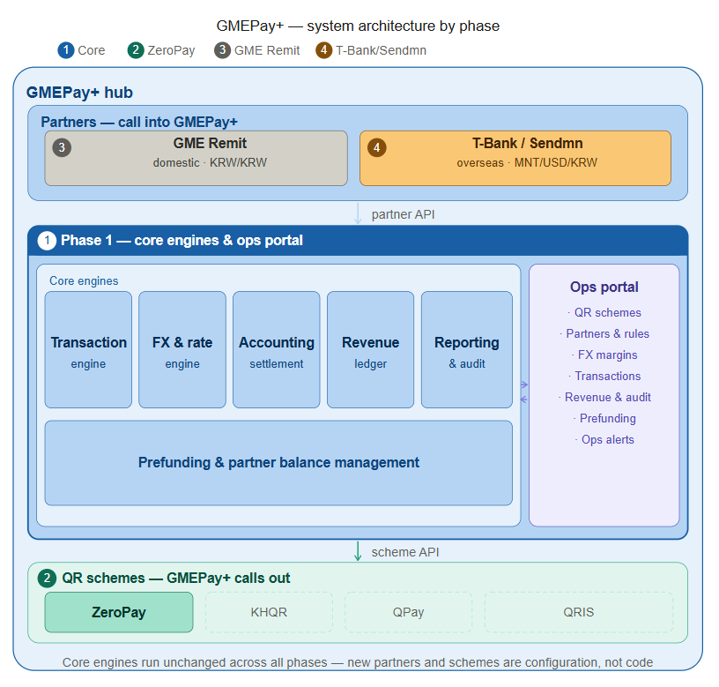
3. Who Uses GMEPay+
User | Role | What they do
GME Ops / Finance | Internal operator | Sets up schemes and partners. Configures rates. Monitors transactions and settlement.
Partner (technical) | Partner integration team | Connects their app via API. Receives payment results via webhook.
End user | Customer of partner app | Pays at a merchant. No direct interaction with GMEPay+.
Merchant | Registered with QR scheme | Receives payment via the scheme. No direct interaction with GMEPay+.

3.1 Partners — Who Connects to GMEPay+
All partners use the same API. Partner type only affects rate configuration:
- Domestic rule (same collection, settle, payout currency, e.g. GME Remit on ZeroPay): m_a = m_b = 0, service charge typically 0; same-currency short-circuit applies (see §5.4).
- Cross-border rule (different settlement currencies): m_a + m_b ≥ 2.0%, service charge in Settle A ccy, prefunding required for OVERSEAS partners.

No special code path for any partner. Every partner is a configuration entry.

Partner type (partner-level)
Type | Settlement currency | Prefund | Examples
LOCAL | KRW | Internal | GME Remit
OVERSEAS | Per agreement (commonly USD) | External | SendMN, T-Bank, Ly Hour, Wing/ABA
All settlement currencies must be on GME’s registered list. v1.2 launches with USD and KRW. Adding a new settlement currency requires GME Ops to populate the corresponding USD↔new_ccy rate in GME’s rate table.

Rules per direction (per-transaction)
Direction | What it covers | Customer origin | Merchant origin
Inbound | Foreign partner customers pay at domestic merchant via domestic scheme | OVERSEAS | DOMESTIC
Outbound | Domestic partner customers pay at foreign merchant via foreign scheme | DOMESTIC | OVERSEAS
Domestic | Domestic partner customers pay at domestic merchant via domestic scheme. Same-currency short-circuit applies | DOMESTIC | DOMESTIC
HUB | Foreign partner customers pay at foreign merchant (e.g. SendMN user at KHQR merchant in Cambodia). Both partners non-Korean; | OVERSEAS | OVERSEAS

3.2 What GMEPay+ Does and Does Not Do

GMEPay+ does | GMEPay+ does NOT do
QR decoding and scheme identification | Hold end-user balances
Payment routing to the correct scheme | Conduct end-user KYC
FX rate quotation and offer rate calculation | Issue wallets to end users
Settlement coordination with scheme operators | Onboard or manage merchants
Prefunding management for partners | Handle customer disputes

3.2.1 Responsibility by Entity

Entity | Responsibility
Partner | User onboarding, KYC, wallet management, customer UX
GMEPay+ Hub | QR processing, routing, FX rates, settlement, revenue reporting
QR Payment Scheme | Merchant onboarding, merchant settlement, scheme compliance

4. Core Capabilities
4.1 QR Scheme Management
For each scheme, the operator sets up:

Scheme identity

- Name and logo (displayed to end users in apps)
- Supported countries — partner provides country_code on CPM prepare call
- Supported payment modes (MPM, CPM, or both — configured per scheme)
- Payout currency (e.g. KRW for ZeroPay, MNT for QPay, THB for PromptPay)

Location-based scheme selection

On CPM payment, the partner app sends country_code to GMEPay+. The partner resolves the customer’s country by any method they choose (device GPS, SIM card, customer selection, etc). GMEPay+ does not process GPS coordinates — country resolution is entirely the partner’s responsibility. GMEPay+ looks up which schemes are active for that country_code: One scheme active → auto-select, returns scheme and prepare_token. No scheme → NO_SCHEME_FOR_LOCATION.

- One scheme active → auto-select, no user input needed
- Multiple schemes → return list for user to choose
- No scheme → NO_SCHEME_FOR_LOCATION error
- Adding a scheme to a country is a backend config change only — no deployment

Example | GPS location | Active schemes | Result
1 | Seoul, Korea | ZeroPay (CPM+MPM) | Auto-selects ZeroPay
2 | Phnom Penh, Cambodia | KHQR (MPM only) | Auto-selects KHQR — CPM not available
3 | Bangkok, Thailand | PromptPay (CPM+MPM) | Auto-selects PromptPay
4 | Border / no GPS | — | Returns NO_SCHEME_FOR_LOCATION

Scheme settlement terms

- Settlement counterparty (e.g. 한결원 for ZeroPay)
- Merchant fee rates by merchant type and payment origin (domestic vs cross-border)
- Fee split between GME and scheme operator (70% GME / 30% ZeroPay)
- Settlement timeline — when GME sends reports and receives fee income

When 한결원 changes fee rates, GME Ops updates the scheme config. No code change needed.

4.2 Partner Management
For each partner, the operator sets up:

Partner identity

- Name and type (Local or Overseas)
- API credentials — key and secret for authentication
- Webhook URL — where GMEPay+ sends payment results
- rate_quote_ttl_seconds: default 300, range 60–1800. Configurable per partner agreement.

Settlement setup

- Collection currency — what partner charges their customers (e.g. THB for a Thai wallet)
- Settlement currency — what GMEPay+ bills the partner (e.g. USD for overseas partners)
- Settlement model: prefunding (overseas partners) or internal (domestic apps)
- Low-balance alert threshold for prefunding partners

Scheme mapping and margin configuration

- Rule configuration (per partner × scheme × direction)
  - Each rule is the join record between a partner and one scheme for one direction. A partner using multiple schemes has one rule per scheme; margins can differ across schemes.
- Currency setup (auto-derived, read-only) The currency triple — collection ccy, settle A ccy, settle B ccy, payout ccy — is derived from the partner profile and the scheme profile. The rule never asks the operator to specify a currency.
- Rate configuration (auto-derived, source can be overridden) Two rates, each showing intermediate-to-Settle pair: USD → settle A ccy (collection-side) and USD → settle B ccy (payout-side). Each rate resolves to one of LIVE / MANUAL / PARTNER / IDENTITY based on currency comparison:
  - IDENTITY when settle ccy = intermediate ccy (no FX needed)
  - LIVE for treasury feed (default for non-IDENTITY legs)
  - MANUAL for treasury override (operator can switch LIVE → MANUAL per rule for contract-locked partners)
  - PARTNER when partner B's quote API is authoritative (configured at scheme level)
The rate structure is auto-derived; the operator can only override the source. For same-currency rules (settle_a = settle_b = payout, e.g. GME Remit on ZeroPay), the system applies the same-currency short-circuit: the USD pool is bypassed entirely, both rates are marked IDENTITY for audit, and collection_amount = target_payout + service_charge directly. See §5.4.
- Margin configuration (operator-entered)
  - m_a — collection-side margin %, applied to collection_intermediate
  - m_b — payout-side margin %, applied to collection_intermediate
- Service charge (operator-entered) Flat per-transaction fee, always denominated in Settle A ccy (partner's settlement currency). Added at STEP 5 of the USD pool sequence. Optional volume-tier table indexed by collection_intermediate.

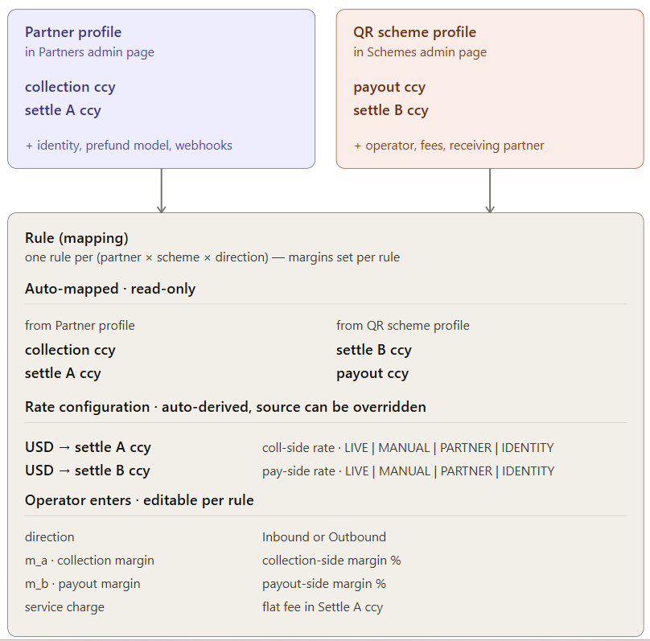
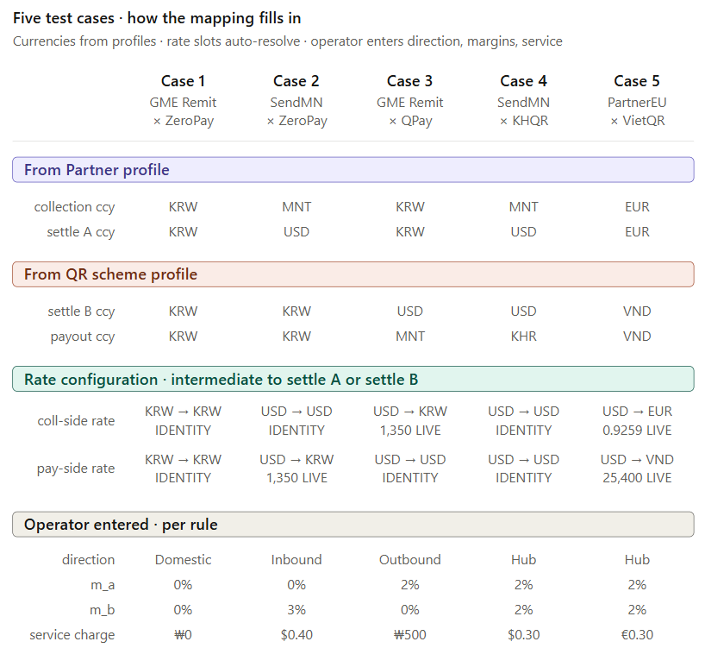
5. How Rates and Fees Work
GMEPay+ uses a three-currency model for every cross-border transaction:

5.1 Three-currency model
Currency | Who controls | Example (French wallet on VietQR)
Collection | Partner A (customer-side) | EUR
Settlement A | Per partner A agreement | EUR
USD Intermediary | GMEPay+ composition (universal intermediary, BOK-required) | USD
Settlement B | Per partner B agreement | VND
Payout | QR scheme | VND

5.2 Rate ownership and storage convention
All treasury rates are stored in one canonical form: treasury.usd_{ccy} = “units of {ccy} per 1 USD.” This aligns with how BOK reporting fields FX1014 (collection) and FX1015 (payout) are structured.
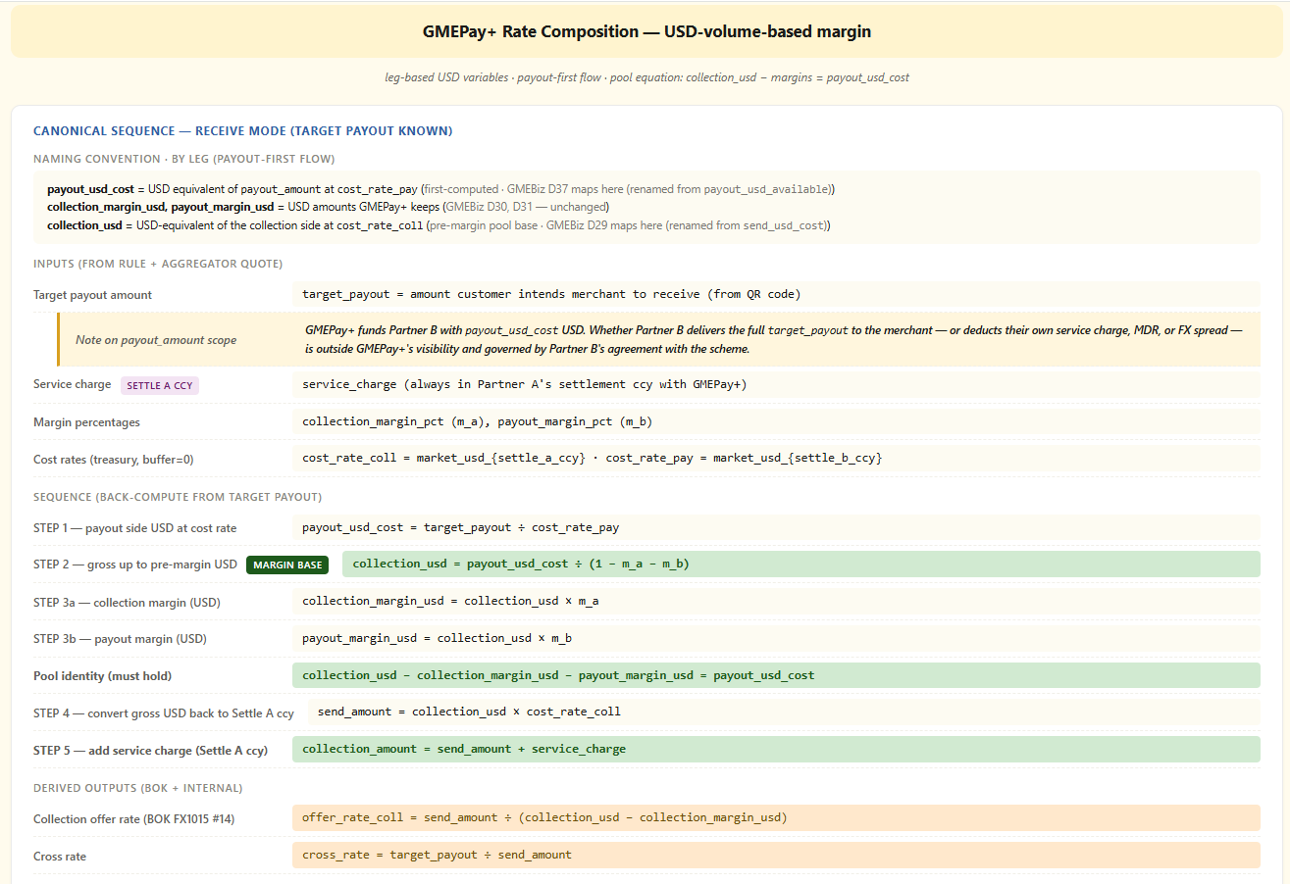
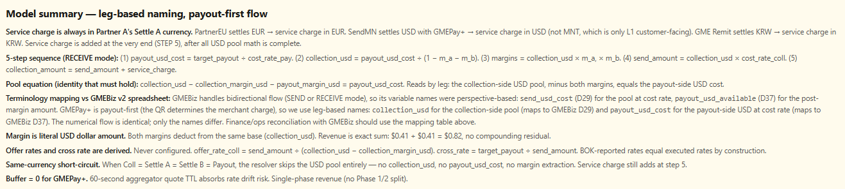

- Inbound
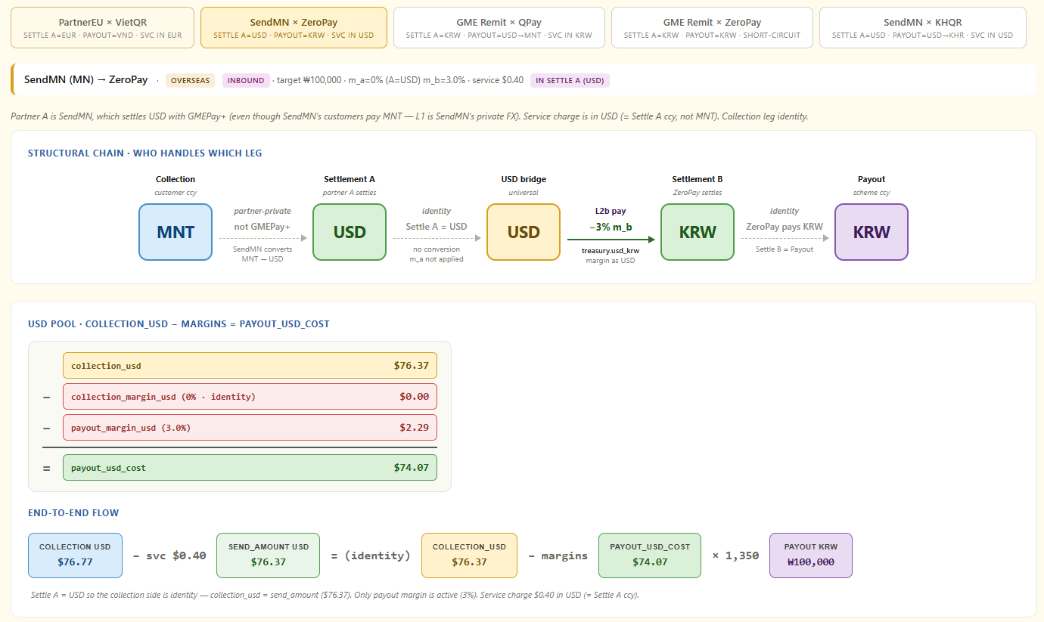
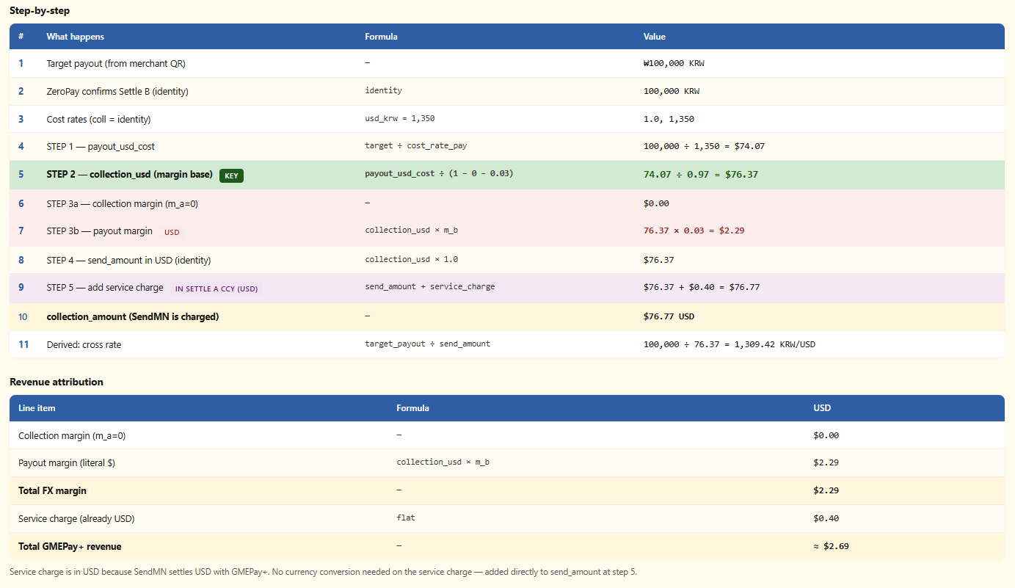

- Outbound
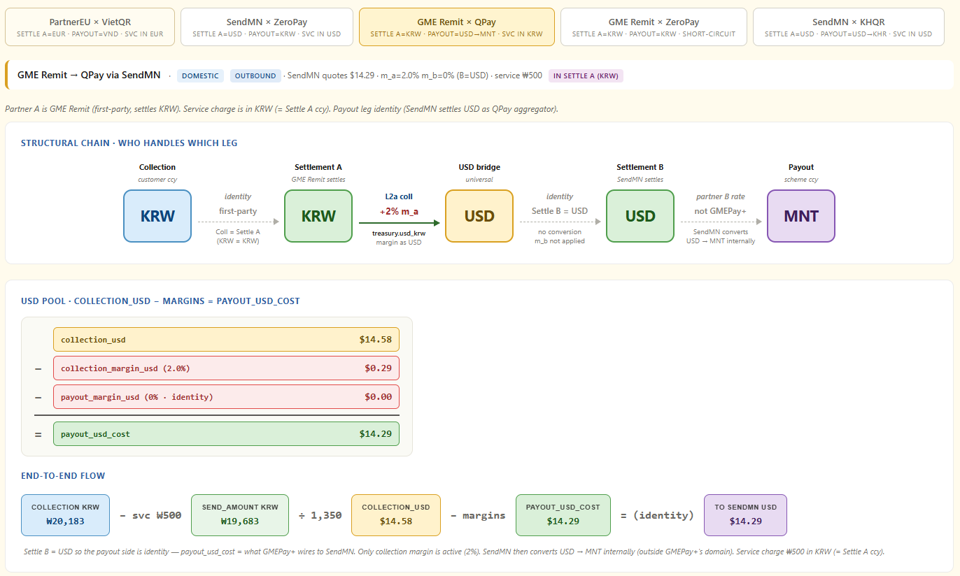
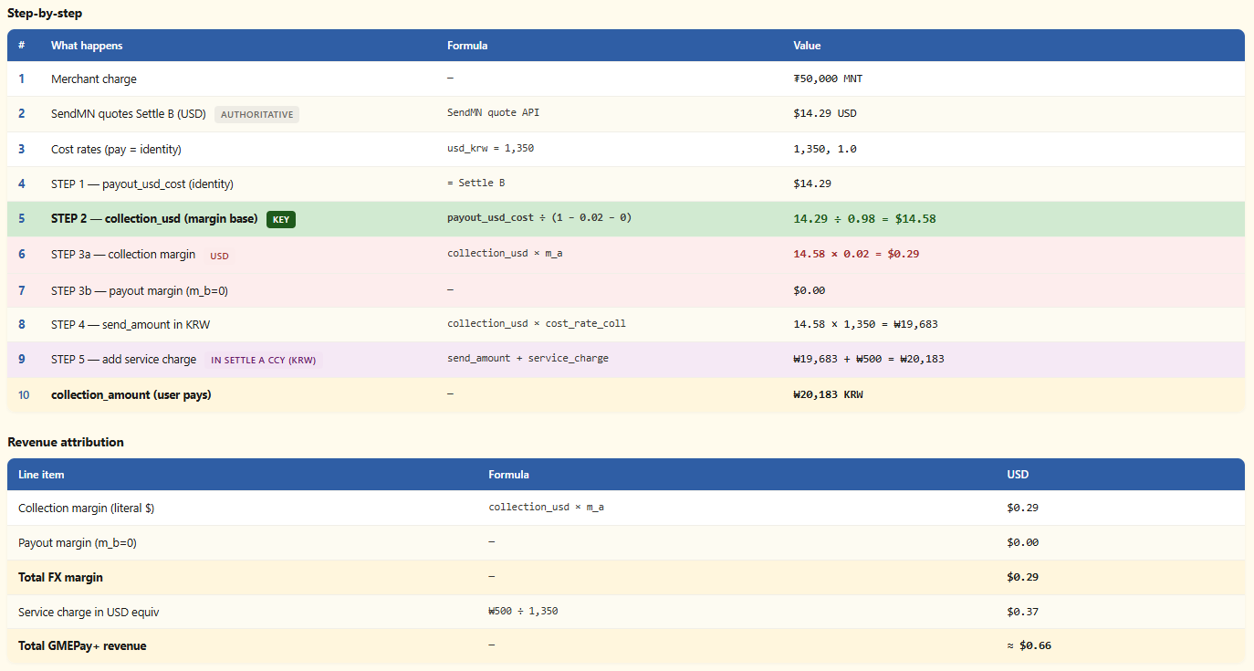

- Domestic
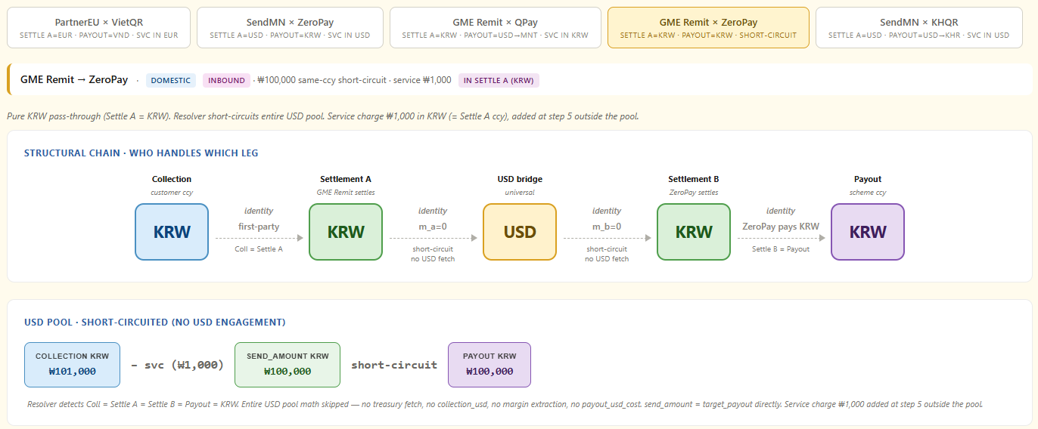
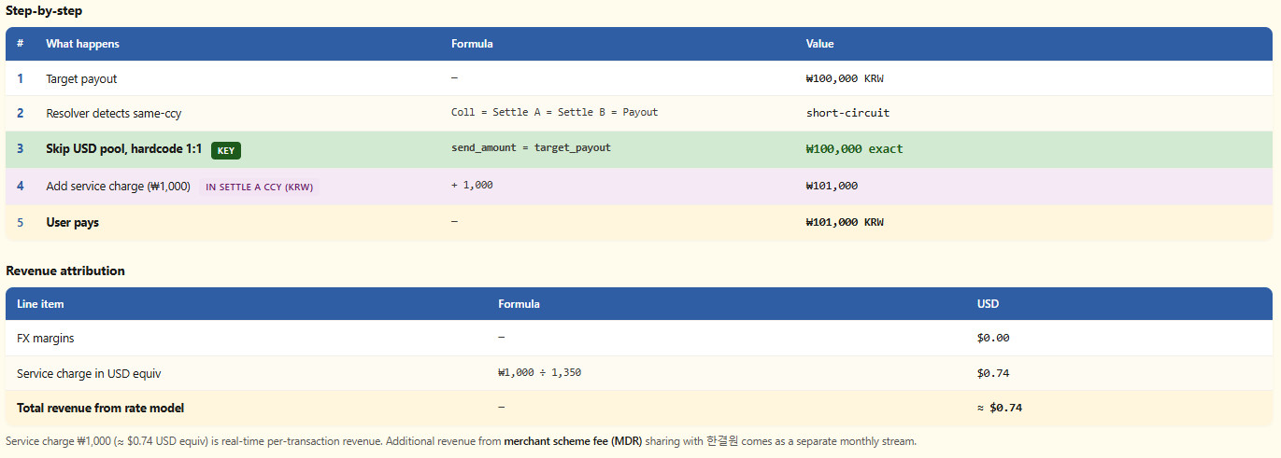

- Hub (USD Settlement)
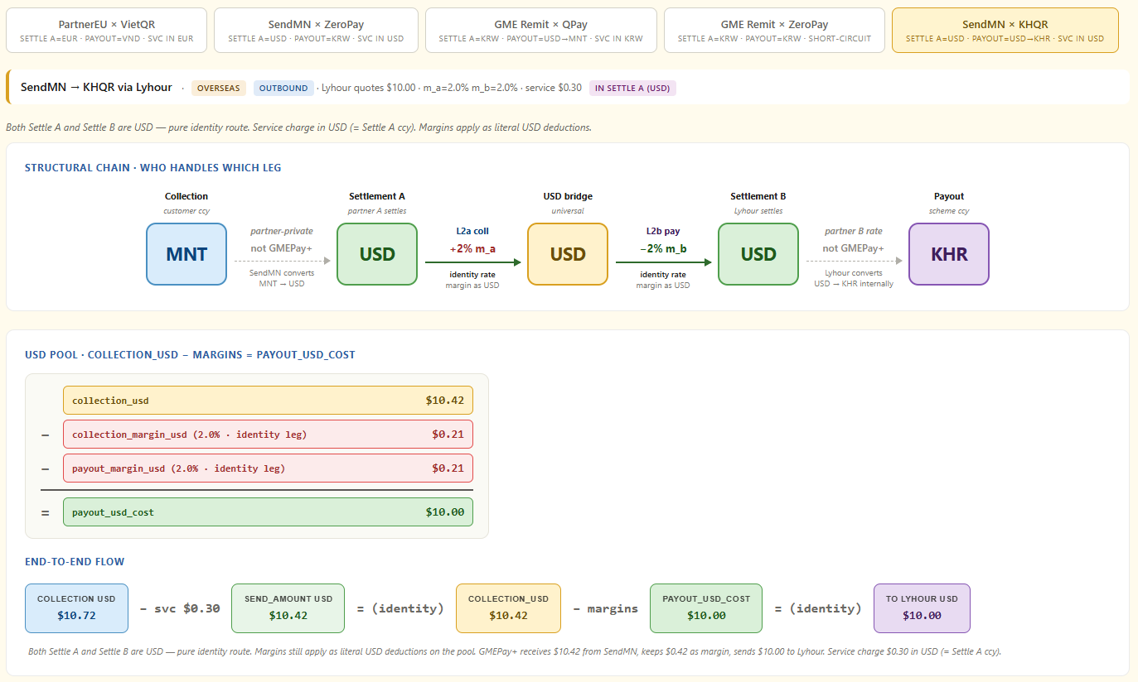
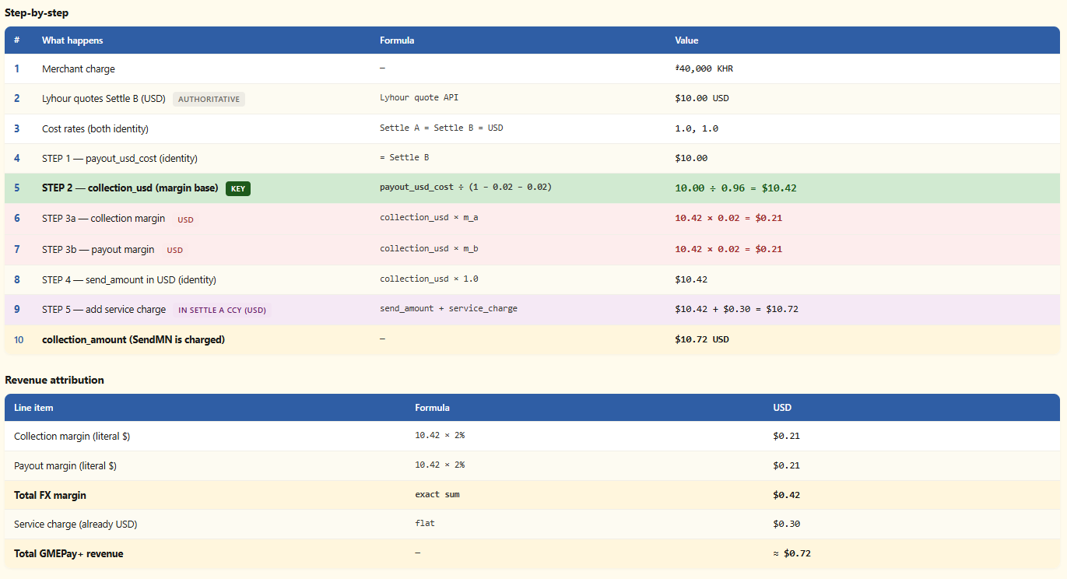
- Hub (non-USD Settlement)
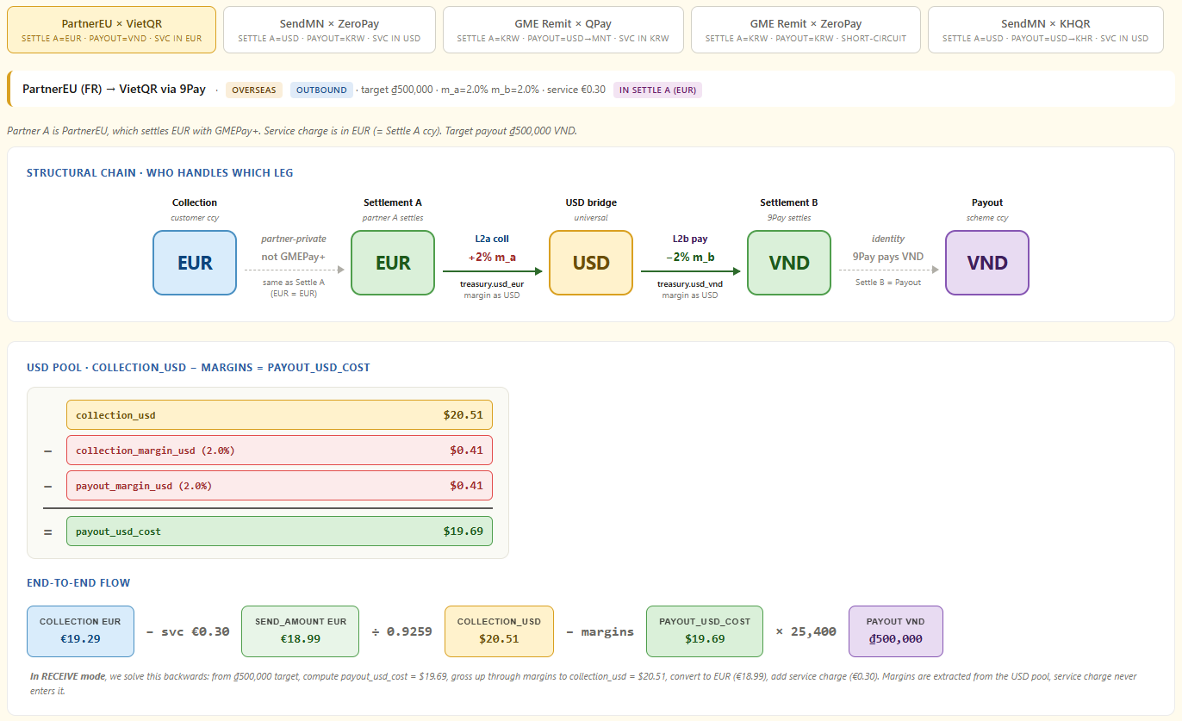
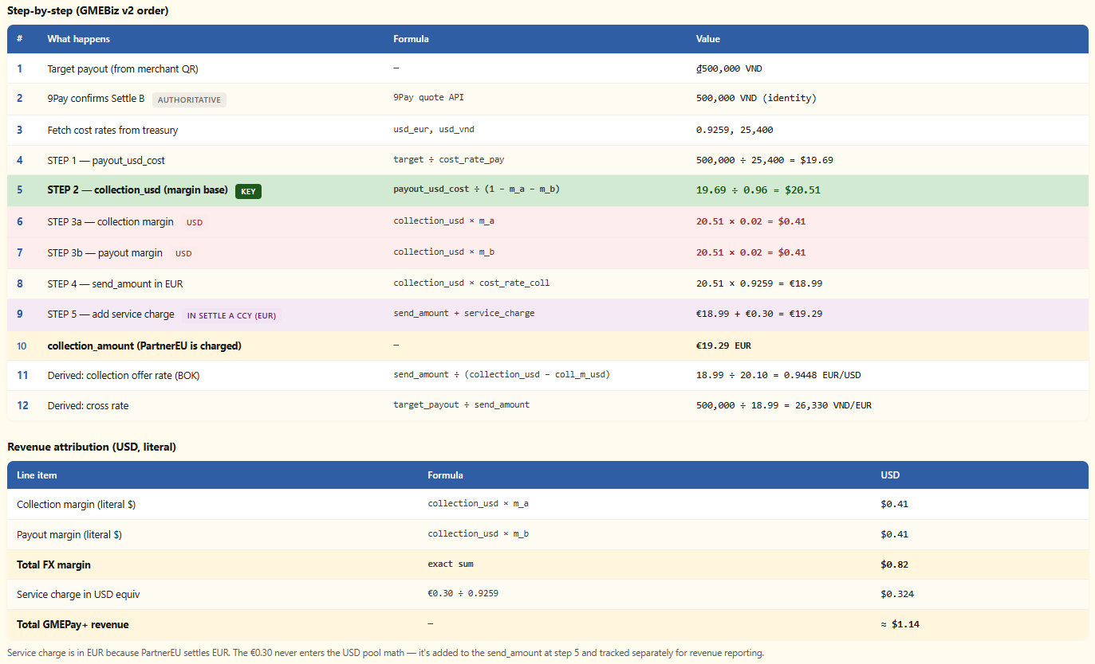

Leg | Pair | Owned by | Source
Private A | collection ↔ settlement_A | Partner A | Partner A’s own FX, never crosses GMEPay+ API
Collection leg | settlement_A ↔ USD | GMEPay+ | cost_rate_coll = treasury.usd_{settle_a_ccy}
Payout leg | USD ↔ settlement_B | GMEPay+ | cost_rate_pay = treasury.usd_{settle_b_ccy}
Private B | settlement_B ↔ payout | Partner B | Partner B’s own FX. If settlement_B ≠ payout, partner B exposes a quote API called by GMEPay+ at transaction time (see §4.1)
What changed from v1.3
v1.3 used rate-based margin: offer_rate_coll = cost × (1 + m_a) and offer_rate_pay = cost × (1 − m_b), composed via cross_rate = offer_rate_pay ÷ offer_rate_coll. v1.4 refactors this to USD-volume-based margin: an explicit collection_usd pool from which both margins are deducted as literal USD dollar amounts. The pool identity collection_usd − collection_margin_usd − payout_margin_usd = payout_usd_cost makes revenue attribution exact (no compounding residual) and aligns with GMEBiz v2 spreadsheet conventions used by GME Finance and Ops. Service charge is now handled separately at STEP 5 in Partner A’s settlement currency, never entering the USD pool. offer_rate_coll and cross_rate become derived outputs (BOK reporting) rather than configured inputs.

5.3 Variable naming — leg-based, payout-first flow
GMEPay+ name | Meaning
payout_usd_cost | USD equivalent of target_payout at cost_rate_pay. First-computed in RECEIVE mode.
collection_usd | USD-equivalent of the collection side at cost_rate_coll. The pre-margin pool. Margins are deducted from this base.
collection_margin_usd | Literal USD amount GMEPay+ keeps from the collection leg. = collection_usd × m_a.
payout_margin_usd | Literal USD amount GMEPay+ keeps from the payout leg. = collection_usd × m_b.
send_amount | collection_usd converted back to Settle A currency at cost_rate_coll. Pre-service-charge.
service_charge | Flat per-transaction charge in Settle A currency. Added at STEP 5.
collection_amount | Final amount Partner A is debited. = send_amount + service_charge.
Why leg-based names. GMEBiz v2 supports both SEND and RECEIVE modes, so its variables describe the USD pool independently of direction (send_usd_cost, payout_usd_available). GMEPay+ is payout-first — the QR fixes the merchant charge — so we always back-compute from the payout amount. Leg-based names (collection_usd, payout_usd_cost) are clearer in the GMEPay+ context, while the numerical mapping to GMEBiz spreadsheet cells is preserved for reconciliation.

5.4 Canonical sequence — RECEIVE mode (5 steps)
Step | What happens | Formula
1 | payout side USD at cost rate | payout_usd_cost = target_payout ÷ cost_rate_pay
2 | gross up to pre-margin USD pool | collection_usd = payout_usd_cost ÷ (1 − m_a − m_b)
3a | compute collection margin | collection_margin_usd = collection_usd × m_a
3b | compute payout margin | payout_margin_usd = collection_usd × m_b
— | pool identity (algebraic) | collection_usd − collection_margin_usd − payout_margin_usd = payout_usd_cost
4 | convert gross USD back to Settle A | send_amount = collection_usd × cost_rate_coll
5 | add service charge in Settle A ccy | collection_amount = send_amount + service_charge
Identity legs. When settlement_A = USD, cost_rate_coll = 1.0 and STEP 4 yields send_amount = collection_usd. When settlement_B = USD, cost_rate_pay = 1.0 and STEP 1 yields payout_usd_cost = target_payout (or the partner B authoritative quote). Margins still apply normally.
Same-currency short-circuit. When collection = settlement_A = settlement_B = payout (pure Domestic pass-through, e.g. GME Remit on ZeroPay), the resolver skips the entire USD pool: no collection_usd, no payout_usd_cost, no margin extraction. collection_amount = target_payout + service_charge directly.
BOK reporting alignment. offer_rate_coll = send_amount ÷ (collection_usd − collection_margin_usd) is derived and maps to BOK FX1015 #14. The treasury storage convention usd_{ccy} matches how BOK reporting fields are structured. The USD intermediate is a regulatory requirement for cross-border payments from Korea.

5.5 Rate quote TTL
Aspect | Rule
Default | 60 seconds for aggregator-bound transactions; 300 seconds otherwise
Configurable range | 60–1800 seconds per partner agreement
Effective validUntil | quote_issued_at + partner_rate_quote_ttl_seconds. For transactions with partner B authoritative quote, bounded by partner B quote validity.
Rate lock | Once a transaction commits, all USD pool values (collection_usd, payout_usd_cost, both margin amounts) and derived rates (offer_rate_coll, cross_rate) are permanently recorded. Subsequent treasury or margin changes don’t affect recorded transactions.
Partner B quote deviation | If commit-time partner B quote differs from /rates-time quote beyond tolerance (default 1.0%, per-partner configurable), transaction is not committed. Hub returns PARTNER_B_QUOTE_DEVIATION.
Partner B quote unavailable | If partner B quote API is unreachable at /rates or /payments time, hub returns PARTNER_B_QUOTE_UNAVAILABLE. No fallback; partner A retries.
Communication | /rates response includes absolute validUntil timestamp (ISO-8601 UTC), plus the full USD pool breakdown and derived rates.
5.6 The Two Revenue Sources

Revenue source | How it works | Applies to | Timing
Scheme fee share | GMEPay+ receives 70% of net merchant fee from scheme operator. | All transactions | Monthly from scheme operator
FX margin + service fee | Margin (m_a + m_b) extracted from the collection_intermediate USD pool. Flat service charge in Settle A ccy added at STEP 5. | Cross-border partners only | Real time from prefunding

5.7 Fee Structure (ZeroPay reference)

Fee item | Domestic partner | Cross-border partner
Merchant fee | 0.8% – 2.0% by merchant type | 1.7% – 2.2% by merchant type
VAN fee | 0.08% – 0.20% | 0.17% – 0.22%
GME fee share | 0.48% – 1.20% (70% of net) | 0.32% – 0.62% (70% of net)
FX margin | None | Min 2.0% combined (m_a + m_b)
Service fee | None | Configurable per partner (e.g. KRW 500)

Full fee analysis, transaction simulations and breakeven in GMEPay+ Fee Structure v0.5.

5.8 Prefunding (Cross-Border Partners)
- Partners maintain a prepaid USD balance with GME
- Deduction timing differs by payment mode: Fixed MPM: deducted when partner calls POST /v1/payments (before scheme call). CPM: deducted when partner calls POST /v1/payments/cpm/generate (when QR token is issued, before merchant scans). In all cases: deduction is atomic (SELECT FOR UPDATE). Scheme is never called without prior successful deduction
- If balance is insufficient, transaction is rejected before reaching the scheme
- Low-balance alerts configured per partner

6. What Operators Need to Be Able to Do
6.1 Setting Up a New QR Scheme
- Register: name, logo, supported countries, payment modes, payout currency
- Enter settlement terms: counterparty, merchant fee table, VAN fees, fee split %
- Set settlement timeline: report due day, payment due day
- Configure connection: API credentials and SFTP settings (stored encrypted)
- Activate: flip from testing to active once integration is verified
Adding a new country to a scheme is a config update. No deployment required.

6.2 Onboarding a New partner
- Register: name, type, webhook URL
- Generate API credentials (shared once, then hashed)
- Map to schemes: select which schemes and modes are allowed
- Set settlement config: settlement currency, settlement model (prefunding or internal). Configure rules per (partner × scheme × direction) — see §6.3 for the four-section mapping page workflow (currency setup, rate configuration, margin, service charge).
- Set settlement: prefunding or internal, low-balance threshold
- Activate: partner can now make live payment requests

6.3 Mapping a partner to a scheme
A rule joins one partner to one QR scheme for one direction. Primary key is (partner × scheme × direction); a partner that uses multiple schemes has one rule per scheme, and margins, rate sources, and service charge are configured independently per rule.
The mapping page is organized into four sections:
- Currency setup — auto-derived from the partner profile (collection ccy, Settle A ccy) and the QR scheme profile (Settle B ccy, payout ccy). Read-only; the rule never asks the operator to specify a currency.
- Rate configuration — auto-derived rate slots: USD → Settle A ccy (collection-side) and USD → Settle B ccy (payout-side). Each slot resolves to IDENTITY, LIVE, MANUAL, or PARTNER based on currency comparison. The operator can override LIVE → MANUAL per rule for contract-locked partners; the slot structure itself cannot be changed. Same-currency rules trigger the short-circuit defined in §5.4.
- Margin configuration — operator enters m_a (collection-side margin %) and m_b (payout-side margin %), both applied to collection_intermediate. Cross-border rules require m_a + m_b ≥ 2.0%; same-currency rules can be 0.
- Service charge — operator enters a flat per-transaction fee in Settle A ccy. Optional volume-tier table indexed by collection_intermediate.
Direction (Inbound, Outbound, Domestic, or Hub — see §3.1) is part of the rule key and is selected by the operator at rule creation. Direction determines which fee tier the scheme applies and which BOK reporting fields are populated.
See §5.2 for five fully-mapped reference cases (Inbound, Outbound, Domestic, Hub USD-settled, Hub non-USD-settled).

6.4 Adjusting a Partner’s Margin
- Update m_a, m_b, service charge, or rate source override with effective date
- Change applies only to new transactions — completed transactions unchanged
- All changes are audit-logged with actor, timestamp, and previous value
6.5 Monitoring Transactions and Settlement
- Real-time dashboard: volume, success rate, prefunding levels per partner
- Transaction search by partner, scheme, date, status, failure origin (request / settlement / payout / internal), failure code
- Settlement batch status: file delivery confirmed, reconciliation results
- Revenue reporting: fee share, FX margin, service fee (always in settlement currency) by partner, scheme, period. Event trail per transaction: 8-step trail from rate_quote_issued through webhook_delivered, with timestamps and duration between steps. Used by CS and Ops for diagnostics.
6.6 Monitoring the partner B quote API
- Admin portal scheme detail shows recent quotes from partner B, quote API health (uptime, p95 latency), and divergence alerts between /rates-time and /payments-time quotes
- Dashboard alerts when partner B quote API p95 latency exceeds SLA (default 500ms)
- Dashboard alerts when partner B quote API returns errors above threshold (default 1% over a 5-minute window)
- Dashboard alerts when a meaningful fraction of quotes show divergence between /rates and /payments time, indicating partner B’s internal FX is volatile
- Audit log of quote calls with partner, timestamp, quote amount, hub_txn_ref, divergence vs /rates-time quote (when applicable)

6.7 Refund processing (Phase 1)
Refunds are via admin portal only in Phase 1. Partner API supports Cancel Payment for same-day reversals only.
7. Key Business Rules
Rule | Description
Rate sourcing | GMEPay+ owns both cost rates: cost_rate_coll = treasury.usd_{settle_a_ccy} and cost_rate_pay = treasury.usd_{settle_b_ccy}. Partner B’s internal FX (settle_B ↔ payout) is out of scope. When partner B settles in a different currency from payout, partner B supplies the authoritative Settle B amount per-transaction via quote API.
Volume-based margin | Margin is a literal USD dollar amount, not a percentage of a rate. collection_margin_usd = collection_usd × m_a; payout_margin_usd = collection_usd × m_b. Both deduct from the same base. Revenue is exact sum, no compounding residual.
Pool identity | Algebraic identity that must hold in implementation: collection_usd − collection_margin_usd − payout_margin_usd = payout_usd_cost. Implementations verify this with appropriate floating-point tolerance (e.g. 0.01 USD).
Service charge separation | Service charge is always added at STEP 5 in Partner A’s settlement currency. Never enters the USD pool math. Tracked separately for revenue reporting.
Derived rates | offer_rate_coll = send_amount ÷ (collection_usd − collection_margin_usd) and cross_rate = target_payout ÷ send_amount are derived from the executed flow, never configured. BOK-reported rates equal executed rates by construction.
Buffer = 0 | GMEPay+ uses cost rates equal to market rates. The 60-second aggregator quote TTL absorbs rate drift risk. No Phase 1/Phase 2 split.
Partner B quote divergence | If partner B’s commit-time quote deviates from the /rates-time quote beyond configured tolerance, transaction is not committed. Hub returns PARTNER_B_QUOTE_DEVIATION.
Partner B quote unavailable | If partner B’s quote API is unreachable, hub returns PARTNER_B_QUOTE_UNAVAILABLE. No fallback.
Prefunding first | OVERSEAS partner payments declined before scheme if prefund insufficient.
CPM prefund at approval | Debited at APPROVED response, not QR generation.
Rate quote TTL | Default 60s for aggregator-bound transactions, 300s otherwise. Partner-configurable 60–1800.
Rate locked at payment | All USD pool values (collection_usd, payout_usd_cost, both margin amounts) and derived rates (offer_rate_coll, cross_rate) permanently recorded on transaction (BOK FX1015 #14); later treasury or margin changes have no effect.
Partner-facing fields | /rates response exposes the full USD pool breakdown plus send_amount, service_charge, collection_amount, and derived rates. Internal rate components (m_a, m_b, cost rates) remain admin-portal-only.
Same-currency short-circuit | collection = settle_A = settle_B = payout → USD pool entirely skipped; collection_amount = target_payout + service_charge. Prevents basis-point drift from non-reciprocal rate pairs.
Minimum combined margin | 2.0% combined (m_a + m_b) hard constraint for cross-border rules; 0 allowed for same-currency.
partner_origin drives fee tier | Fee tier applied by scheme depends on partner_origin.
uncertain resolution | Hub reconciles uncertain → success/failed within 24h via scheme batch.
country_code determines CPM scheme | Partner does not specify scheme_id unless multiple active schemes.
Refunds admin-only in Phase 1 | No partner-facing refund API.

8. What We Are Not Building
Out of scope | Why
partner app UIs | GMEPay+ provides the backend API only. Each partner builds their own app.
Partner self-service portal | All partner setup done by GME Ops in Phase 1.
New QR schemes beyond ZeroPay | KHQR, QPay etc. added as config entries once platform is live.
Merchant-facing features | Merchants interact with their QR scheme, not GMEPay+.
Live FX rate feed | Market rates updated manually by GME Ops in Phase 1.
Refunds via API in Phase 1 | Managed internally by GME Ops via admin portal.

9. Success Metrics
Metric | Target | Timeframe
New scheme configurable without code change | Zero deployments needed | From day one
New partner onboardable without code change | Zero deployments needed | From day one
GME Remit live on ZeroPay | MPM and CPM working end-to-end | October 10, 2026
First overseas partner connected | At least one external partner processing live transactions | 3 months post-launch
Payment success rate | Above 98% for completed attempts | Monthly
Settlement batch delivery | 100% on-time to 한결원 | Monthly
Operator setup time | New scheme or partner in under 30 minutes | From day one
— End of Document —

